

|  |
| --- |
| DATEMANDU |
|  |
| February 13  CodexOrient |



# Introduction

## DATEHACK

Brainycube Research Organization with and at Sunway International Business School organized a 24-hour hackathon.

The problem given is that people are finding hard to choose a perfect partner and for that problem we coders are required to find out a solution to the problem.

In order to do so we team CodexOrient came up with a solution DATEMANDU, a dating site and a mobile application.

Our current aim is to help single people to find a partner with some clicks. To do we will develop a prototype which will have the feature to connect two single people based on their preference.

Problems

The problems seen for people who are single are:

* Difficulty in communicating
* Difficulty in finding the perfect partner in this huge pool of people.
* The app that are available are not that much applicable.

Proposed Solution Strategies

In order to help singles we proposed a system in which our algorithm matches the people having similar interest and with their user information we shall find the best match for them.

Aims

* Make use of new and improved technology.
* Provide online matching of compatible clients. (Example: Matching through horoscope)
* Bring innovation to be socialize by advertising online.
* Including with messages to connect more effectively.
* Our website and app can make best use of the recent advancements in the technology so that they can attract more clients and serve the existing clients in a better way.

Objective

For all the people in Nepal who are single and in search for their special someone, DateMandu is an online matchmaking platform that will help them to find the companion they are looking for. The app allows the users to create a profile on its website to search for their suitable partners without the need to display much of their personal information. The information held is fully confidential and secure. Unlike the current matching system our new system will provide the customers with the option of only local (Nepal) online dating allowing them to find their partners in no time. The customers will be able to interact with their partners effectively and a lot of time will be saved in finding the right match.

Benefits:

Matching through horoscope – One of the unique features of this system is that it provides matching compatible by matching the horoscope of user. As this system is developed considering the Nepali market. So, match pair our society also believe in horoscope and kundli. For the prototype version the horoscope feature is integrated and the kundli can be extended for the future enhancement of cover more of the Nepali market.

Increased revenue from membership fee – There will be an increase in revenue as with new services there will be increase in demand for the membership of the system in further upcoming versions.

Better throughput – The profiles of the clients will be made available in less time thus the process of adding members will increase. It will be not like asking lots of questions like other system in the market. Example: eharmony.

Increased customer satisfaction – As the services provided will be faster and more proficient the customers will be satisfied to a greater extent.

Fast profile matching – With online profile matching locally only for Nepal the compatible list can be generated in very less amount of time thus speeding up the process of dating.

Fewer Complaints – With the matches been made available in less time there would be fewer problems in related to the delivery of matches and hence the complaints from the clients will also decrease.

Increased reliability – The dating system will be more reliable as the matches are made online which will result in the decrease in human errors and the success of delivery of results will increase.

Functional requirements

1. Account
   1. Creating user profiles
   2. Managing user profiles
   3. Registration

2. Profile matching

2.1 Search the users database

2.2 Match the compatible profiles (Example: Matching through horoscope)

2.3 Display the matching profiles

3. Customer support

3.1 Listening to and providing solutions to customer complaints

5. Online dating

5.1 Provide online compatibility matching

5.2 Fast dating

6. Payments (Future enhancement)

6.1 Make payments for the membership

6.2 Record payments

6.3 Printing statements of the payments made

6.4 Accept membership fee

7. Editing user profiles

7.1 Modification to user records by the user any number of times

7.2 Deletion of personal profile

8. Maintaining database

8.1 Creating a database containing user information

8.2 Updating the database

8.3 Deleting the profiles from the database who do not want to have an account

9. Advertisement (Future enhancement)

9.1 Increase in online advertisements

9.2 Better graphical advertisements

Non-functional requirements

Software Quality Attributes

1. Availability: The system should be available to the users any time of the day so that they can use it according to their ease.
2. Reliability: The capacity of the system should also be planned so that it can handle any amount of user traffic anytime and should not slow down when lot of users are accessing the service at the same time.
3. Usability: The usability of the system is vast as we can use it in both web and phone.

Security Requirement

1. User should be asked for verification username and password so that only authorized users can access the service.
2. Ensure that only authorized users can modify the account details and personal information of their own profiles.
3. The transactions made online through credit cards should be totally secure so that no theft takes place. (Future enhancement)

Legislative Requirements

1. The system should comply with rules and regulations of the Data Protection Act.
2. Personal information provided by the users should be kept confidential i.e., should not be shared with any other entity without the prior permission of the person.

Product Requirements

1. The software used for providing the service should be easy to upgrade.
2. The system should be able to work with all the standard applications.
3. The maintaining of the database should not be outsourced to a third party.

Use Case Diagram

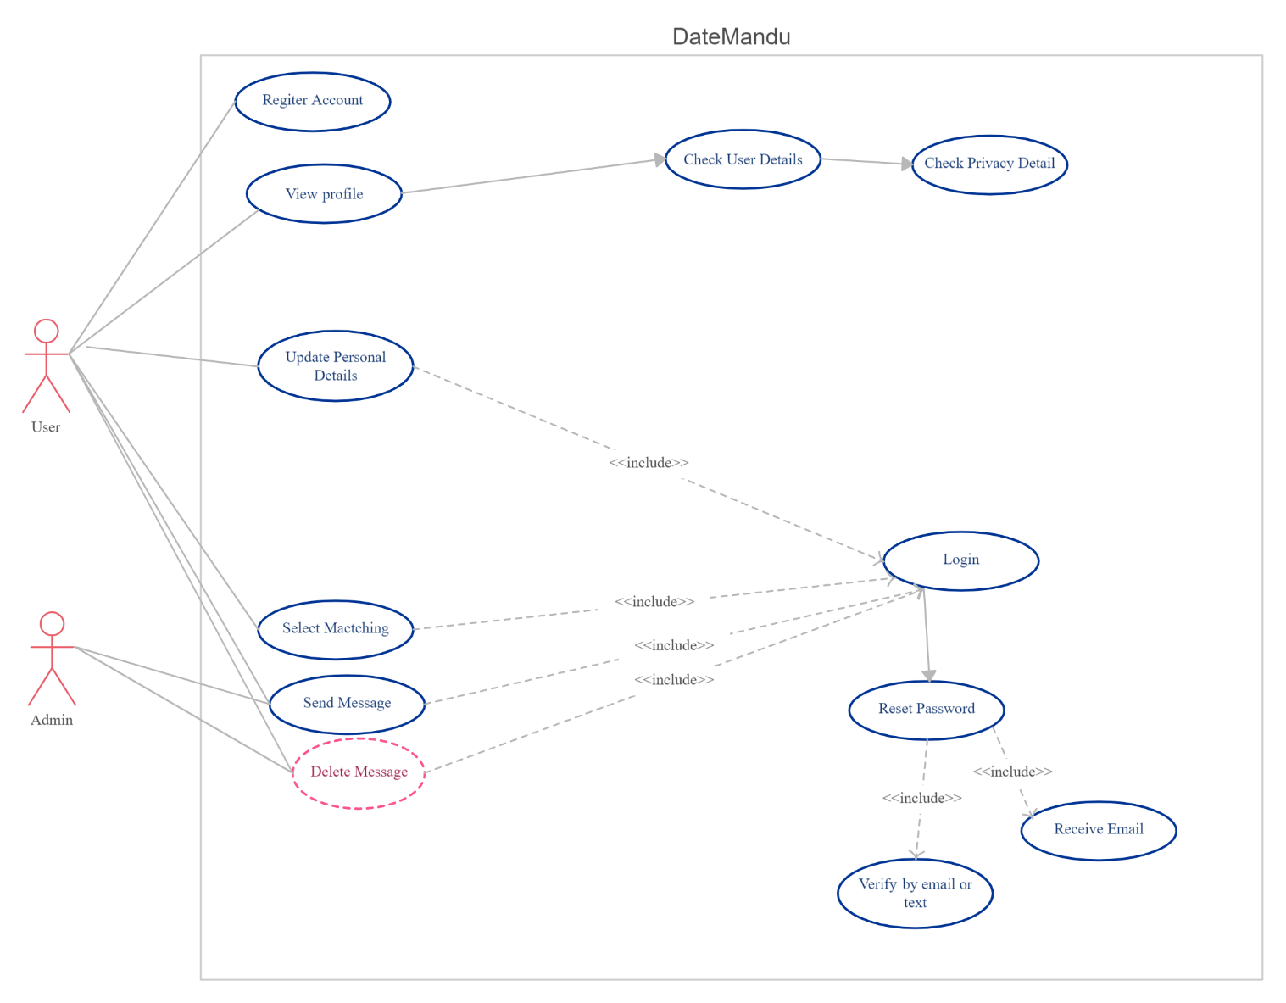

Database Schema

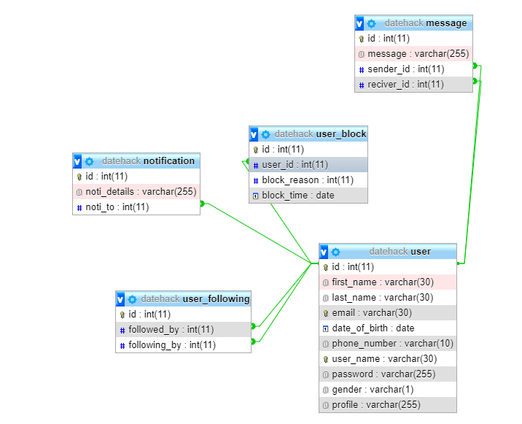

Fig 30: Database Schema

Wireframes(Web)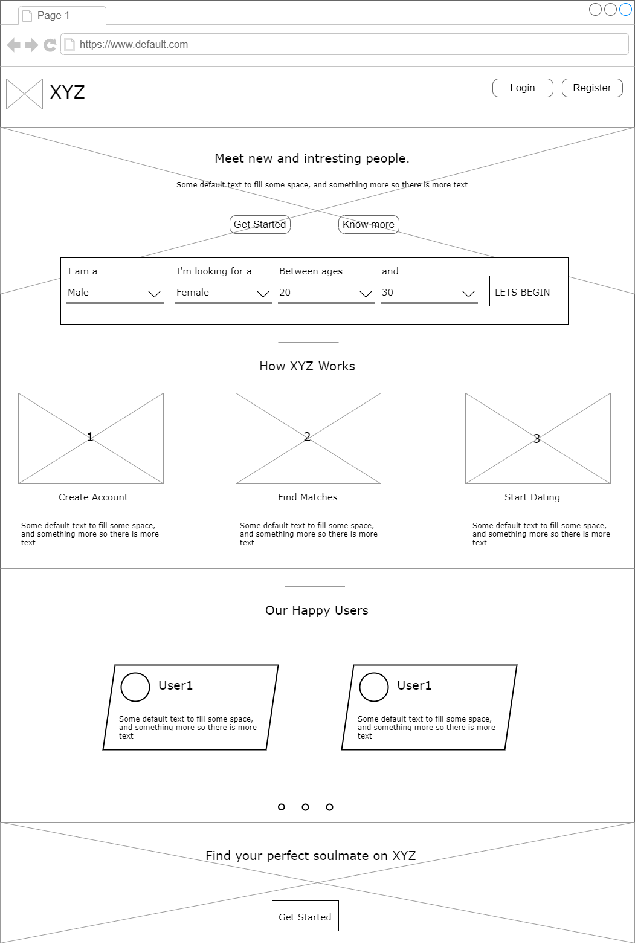

Fig 1: Landing Page

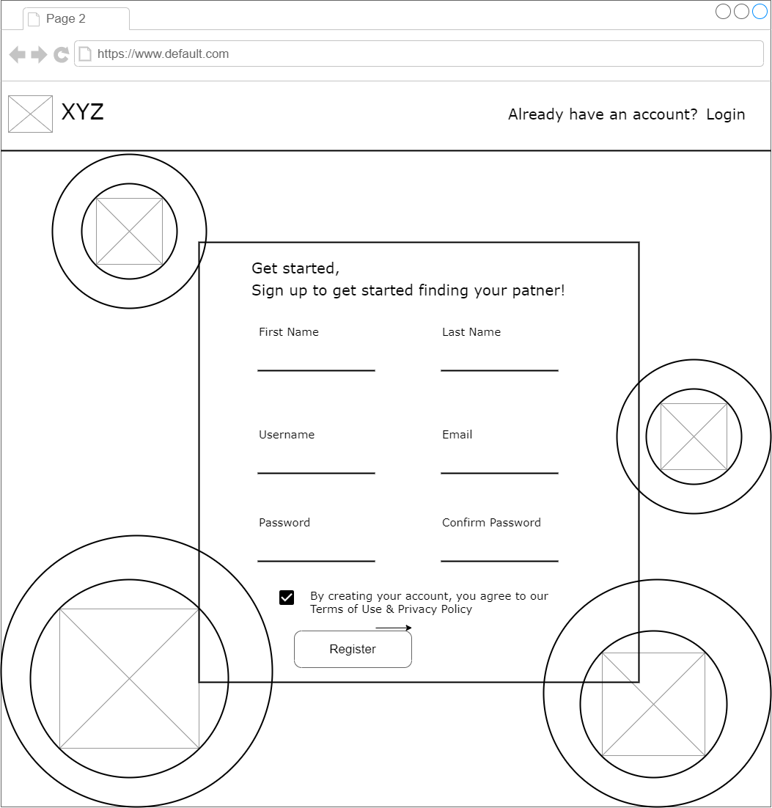

Fig 2: Registration Page

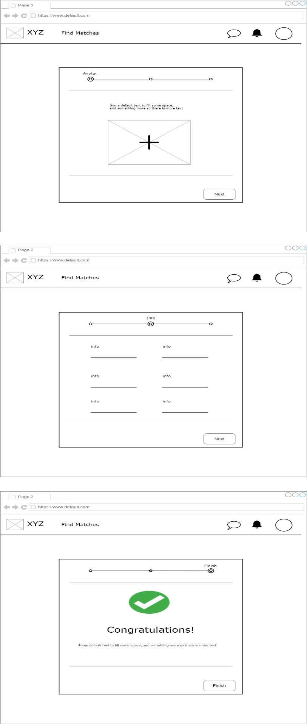

Fig 3: Profile update page

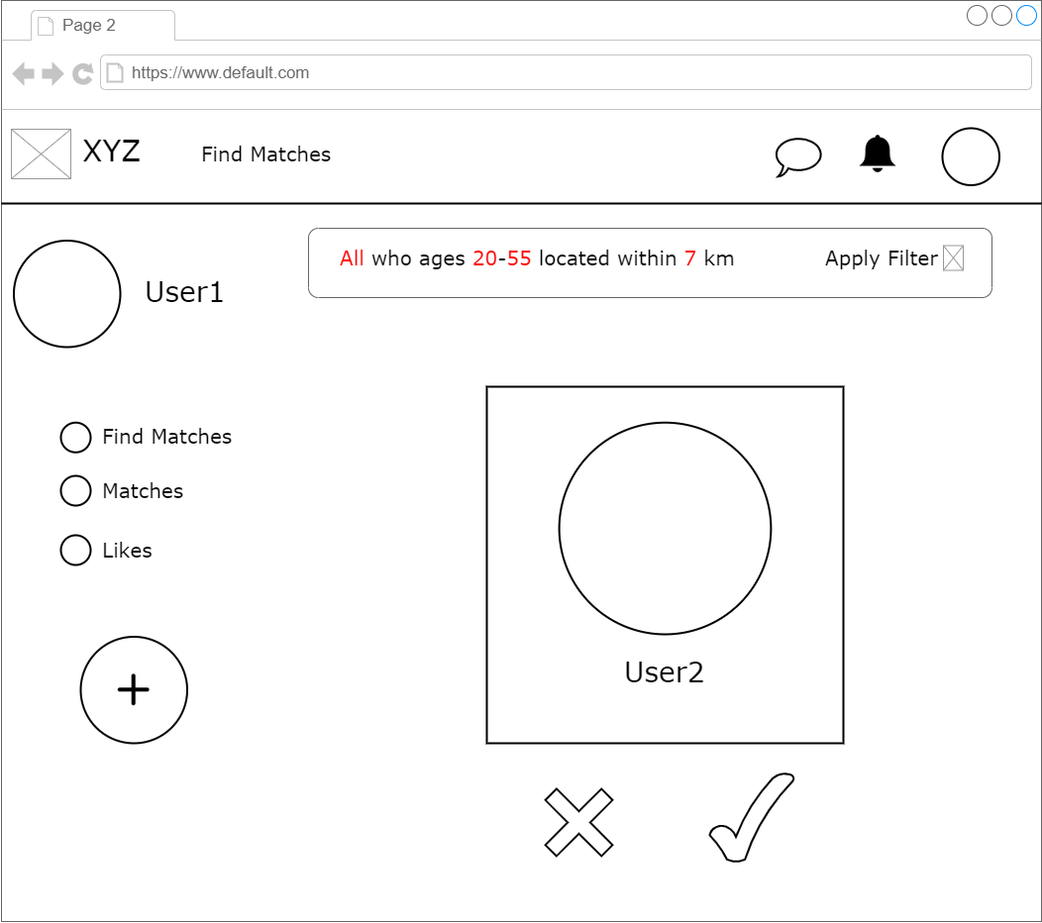

Fig 4: Match Finding page

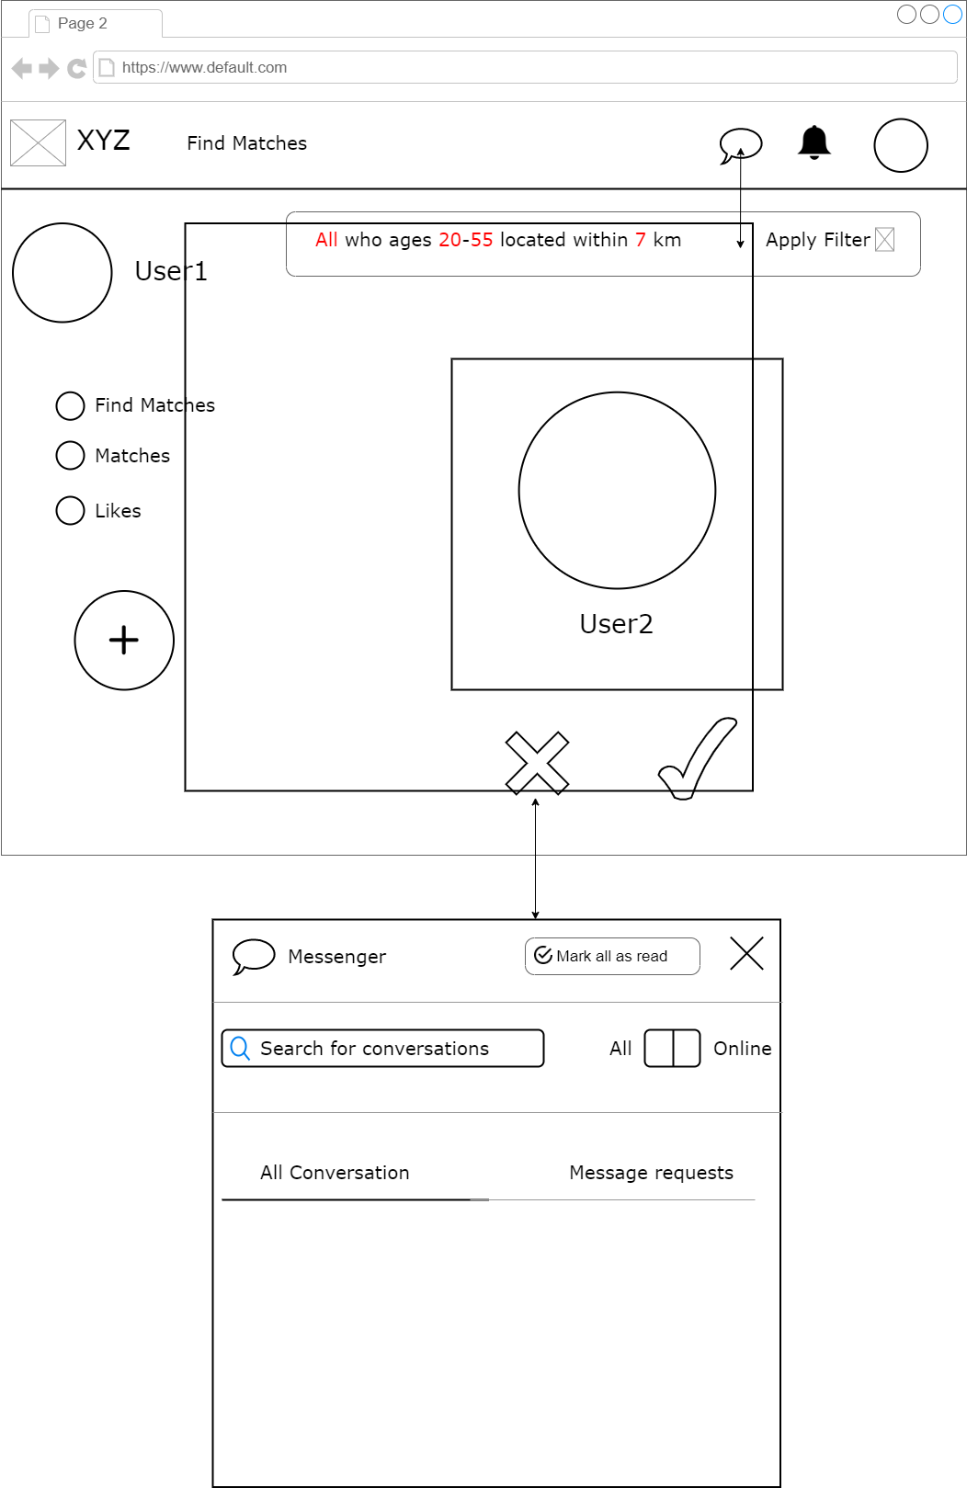

Fig 5: Messaging page

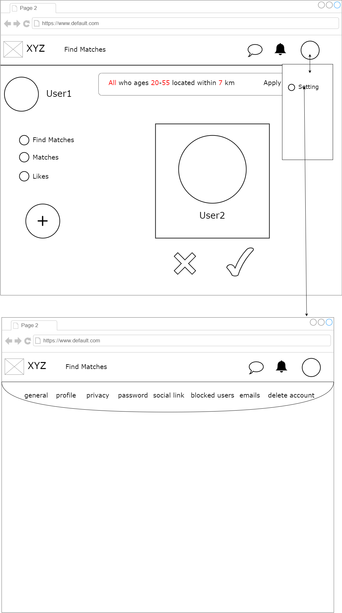

Fig 6: Setting page

Wireframes(Mobile)

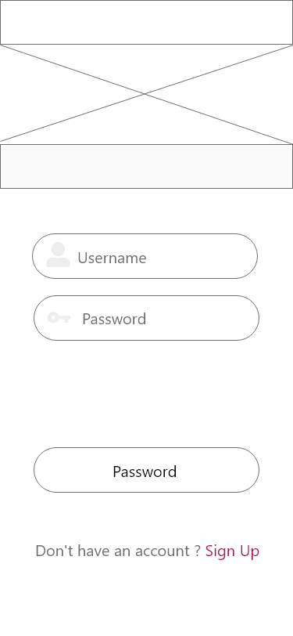

Fig 7: Login page

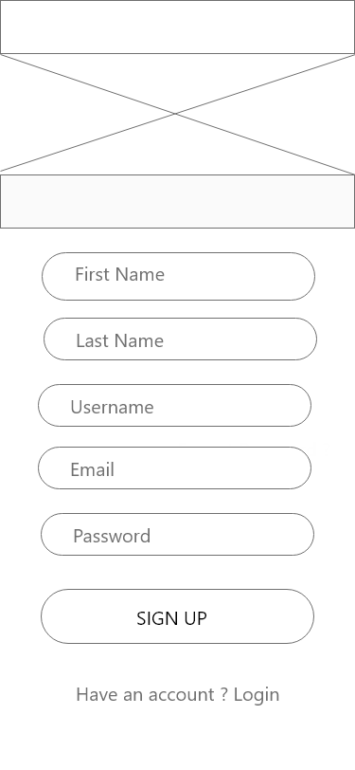

Fig 8: Sign Up page

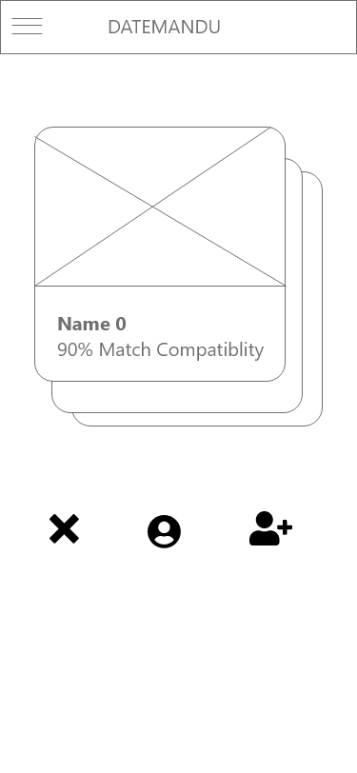

Fig 9: Swipe page

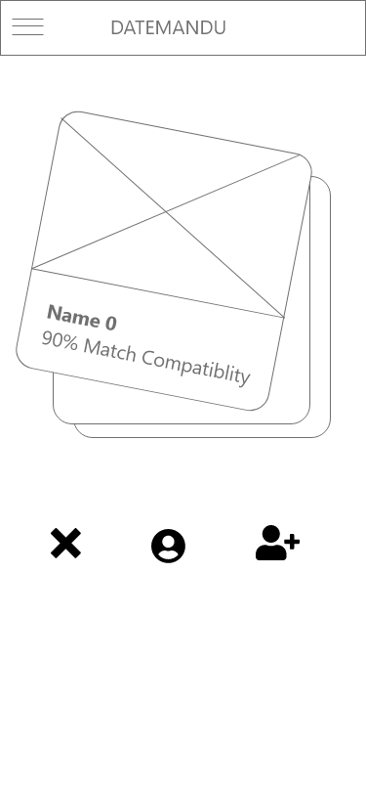

Fig 10: Swipe left

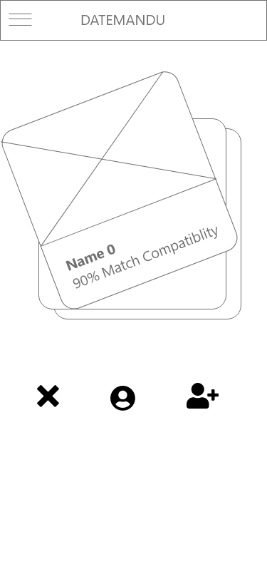

Fig 11: Swipe right

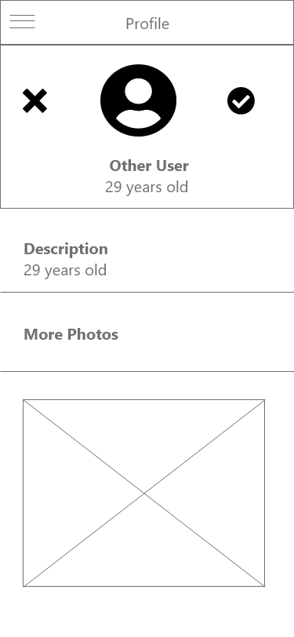

Fig 12: Profile page

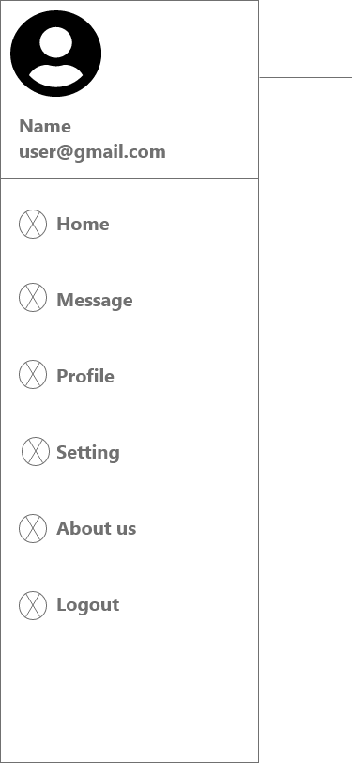

Fig 13: side bar

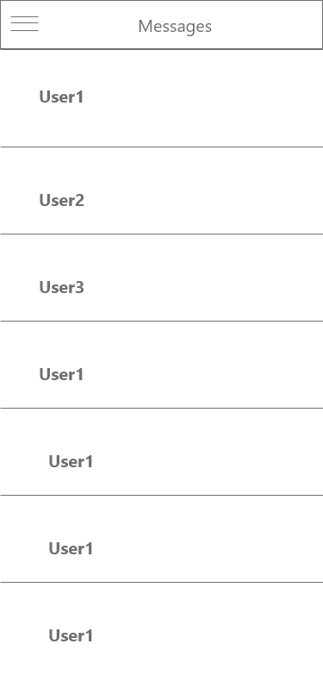

Fig 14: Message page

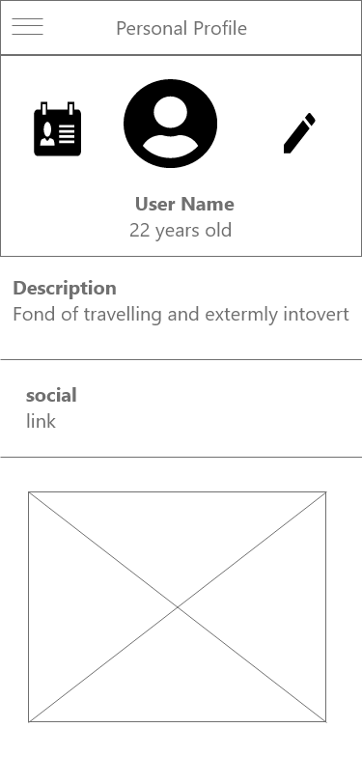

Fig 14: Personal profile page

Mockups(Web)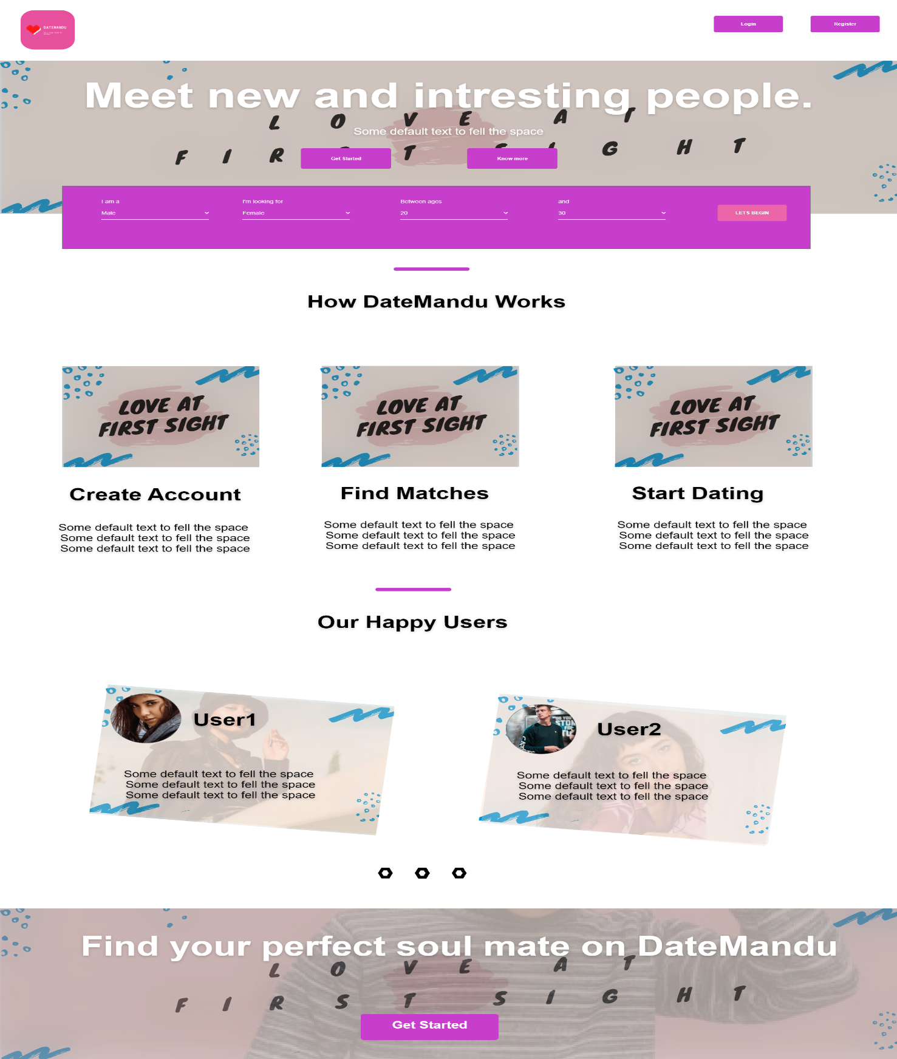

Fig 15: Landing Page

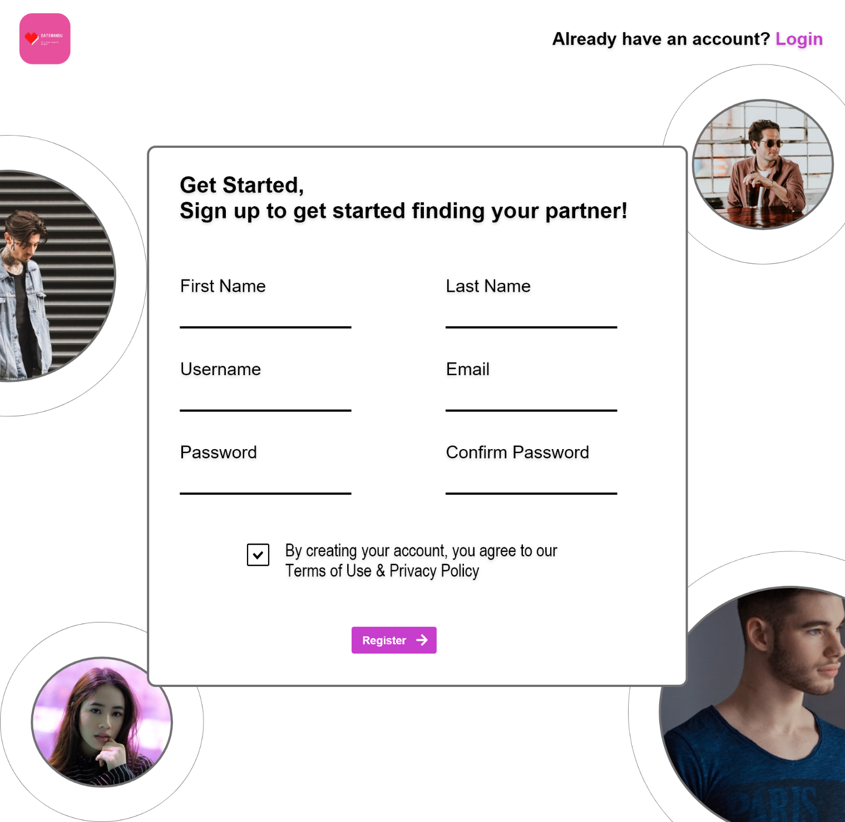

Fig 16: Registration Page

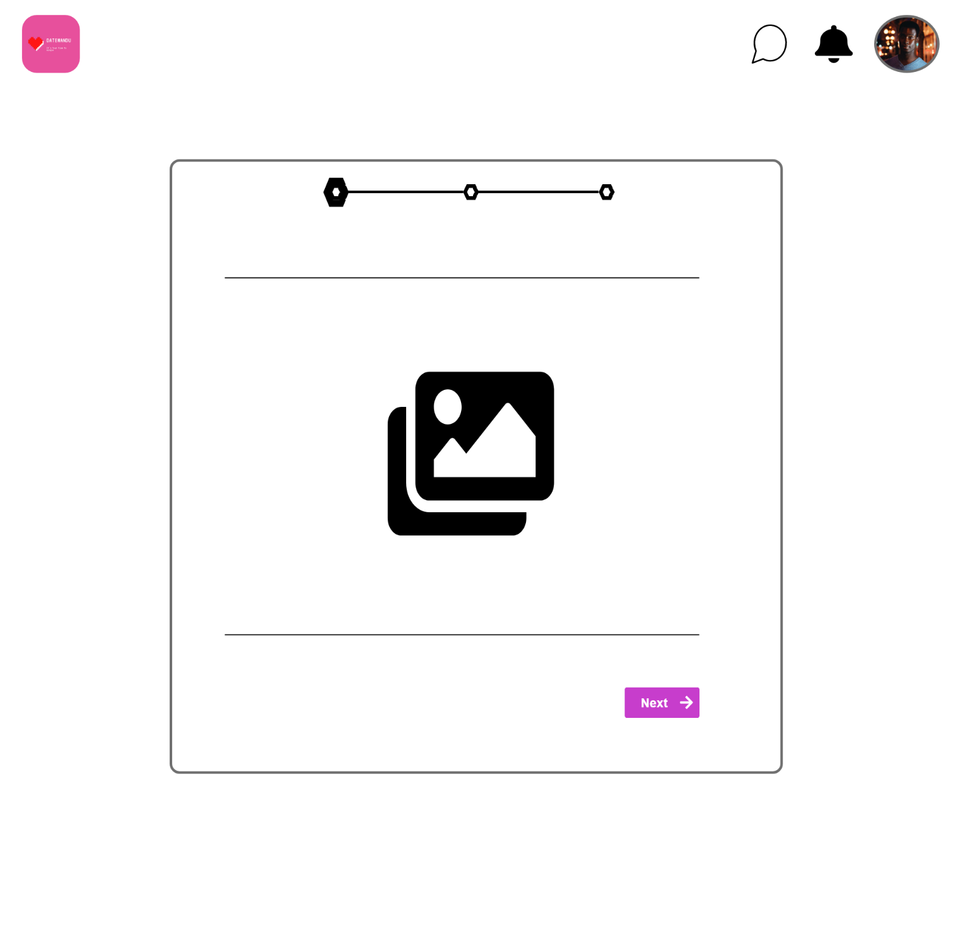

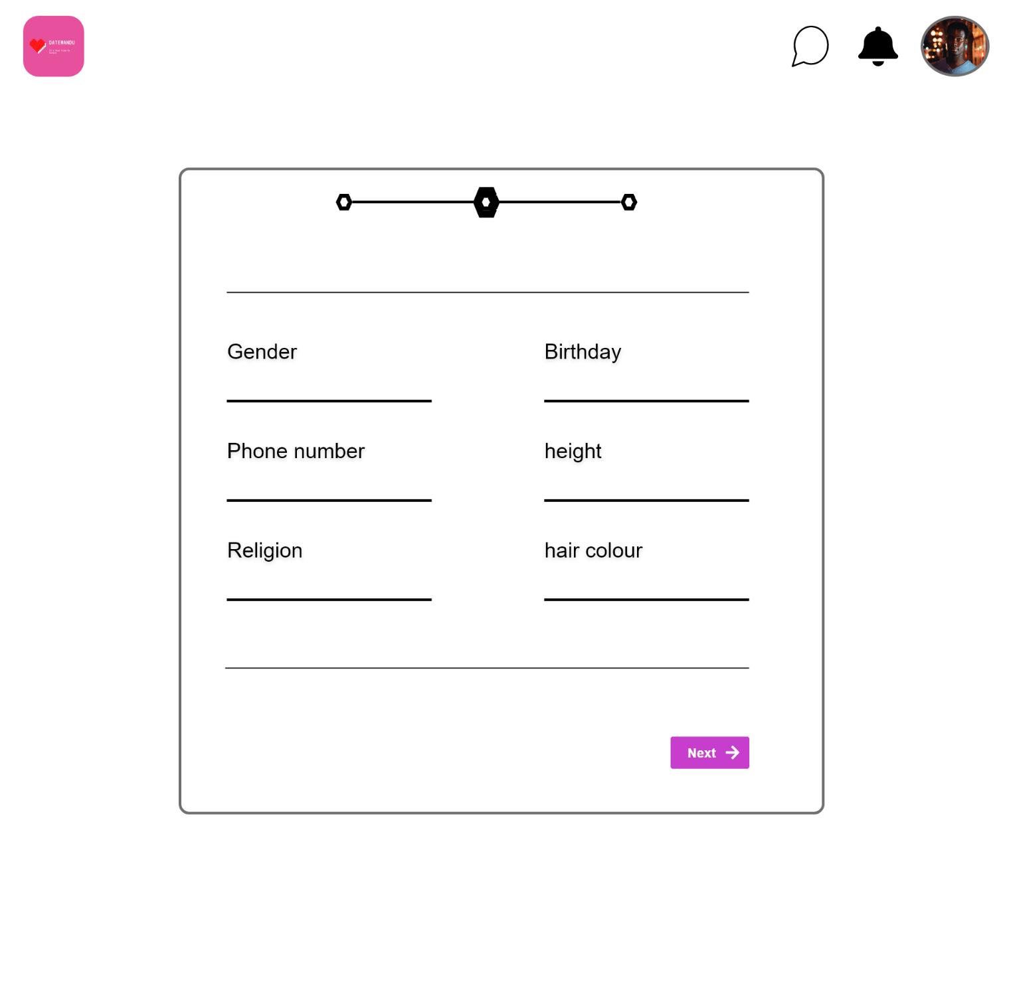

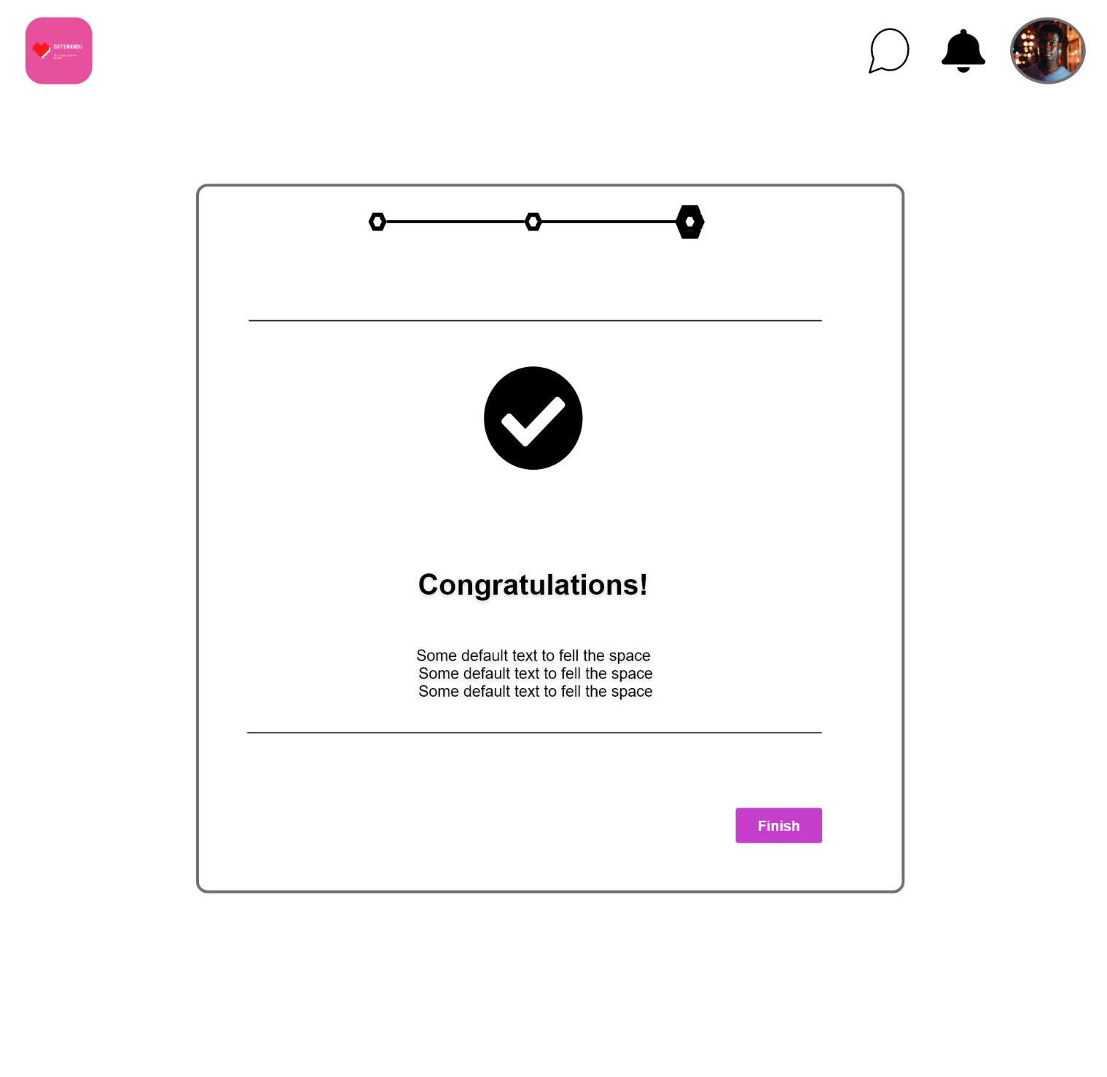

Fig 17: Profile update page

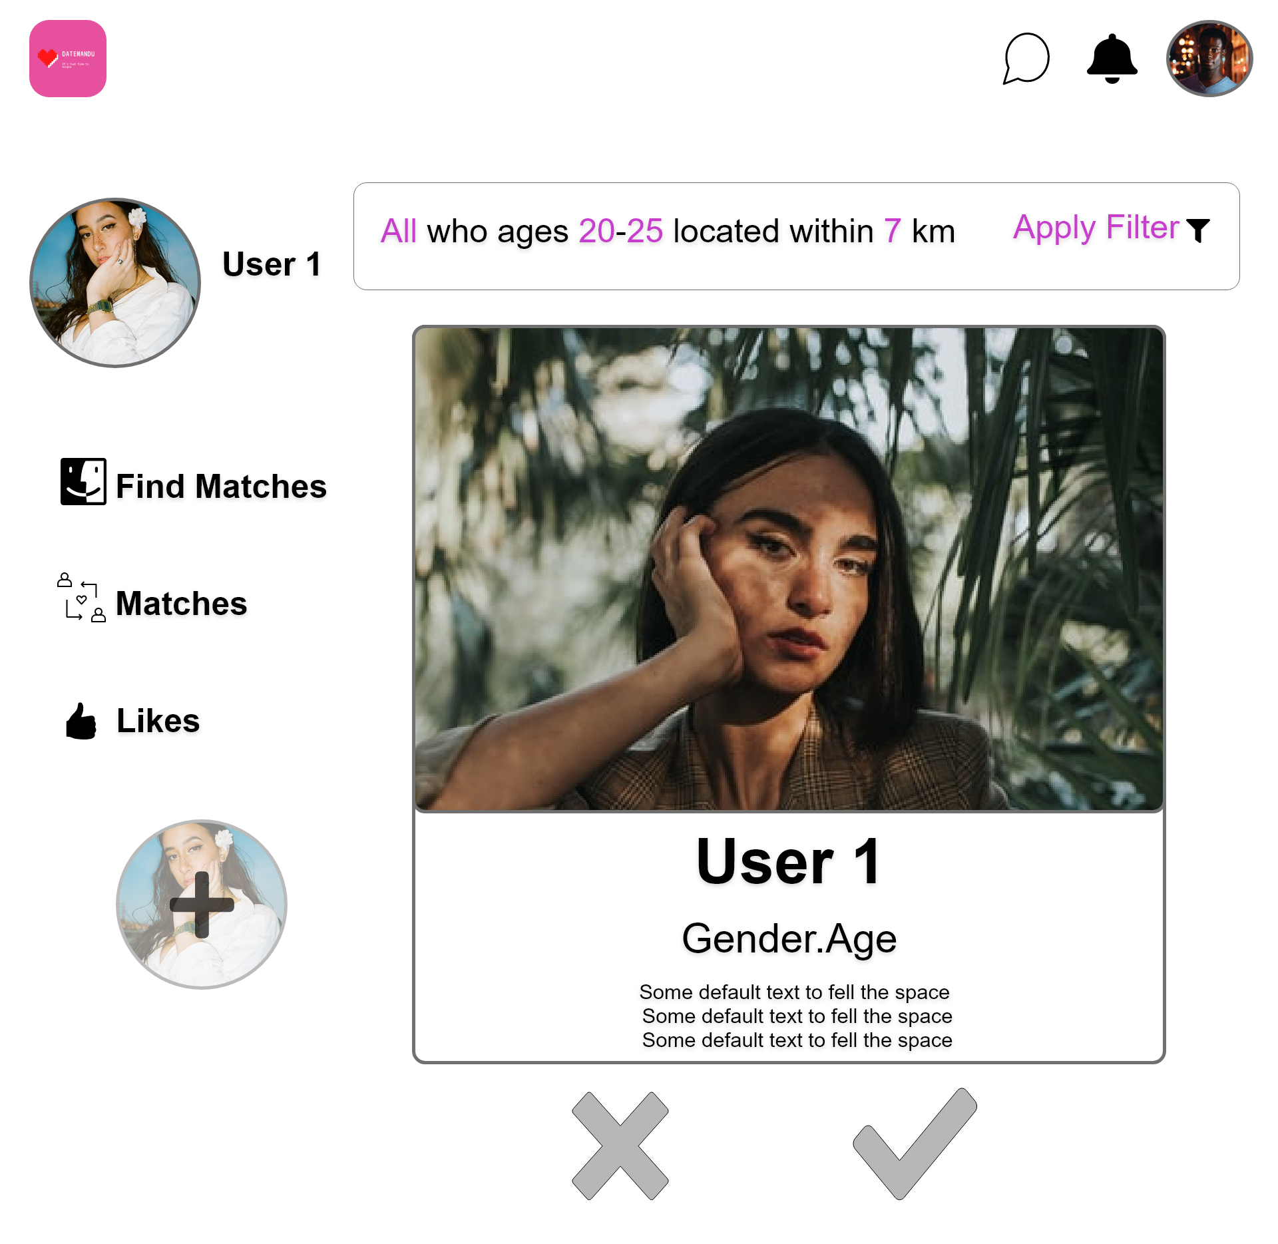

Fig 18: Match Finding page

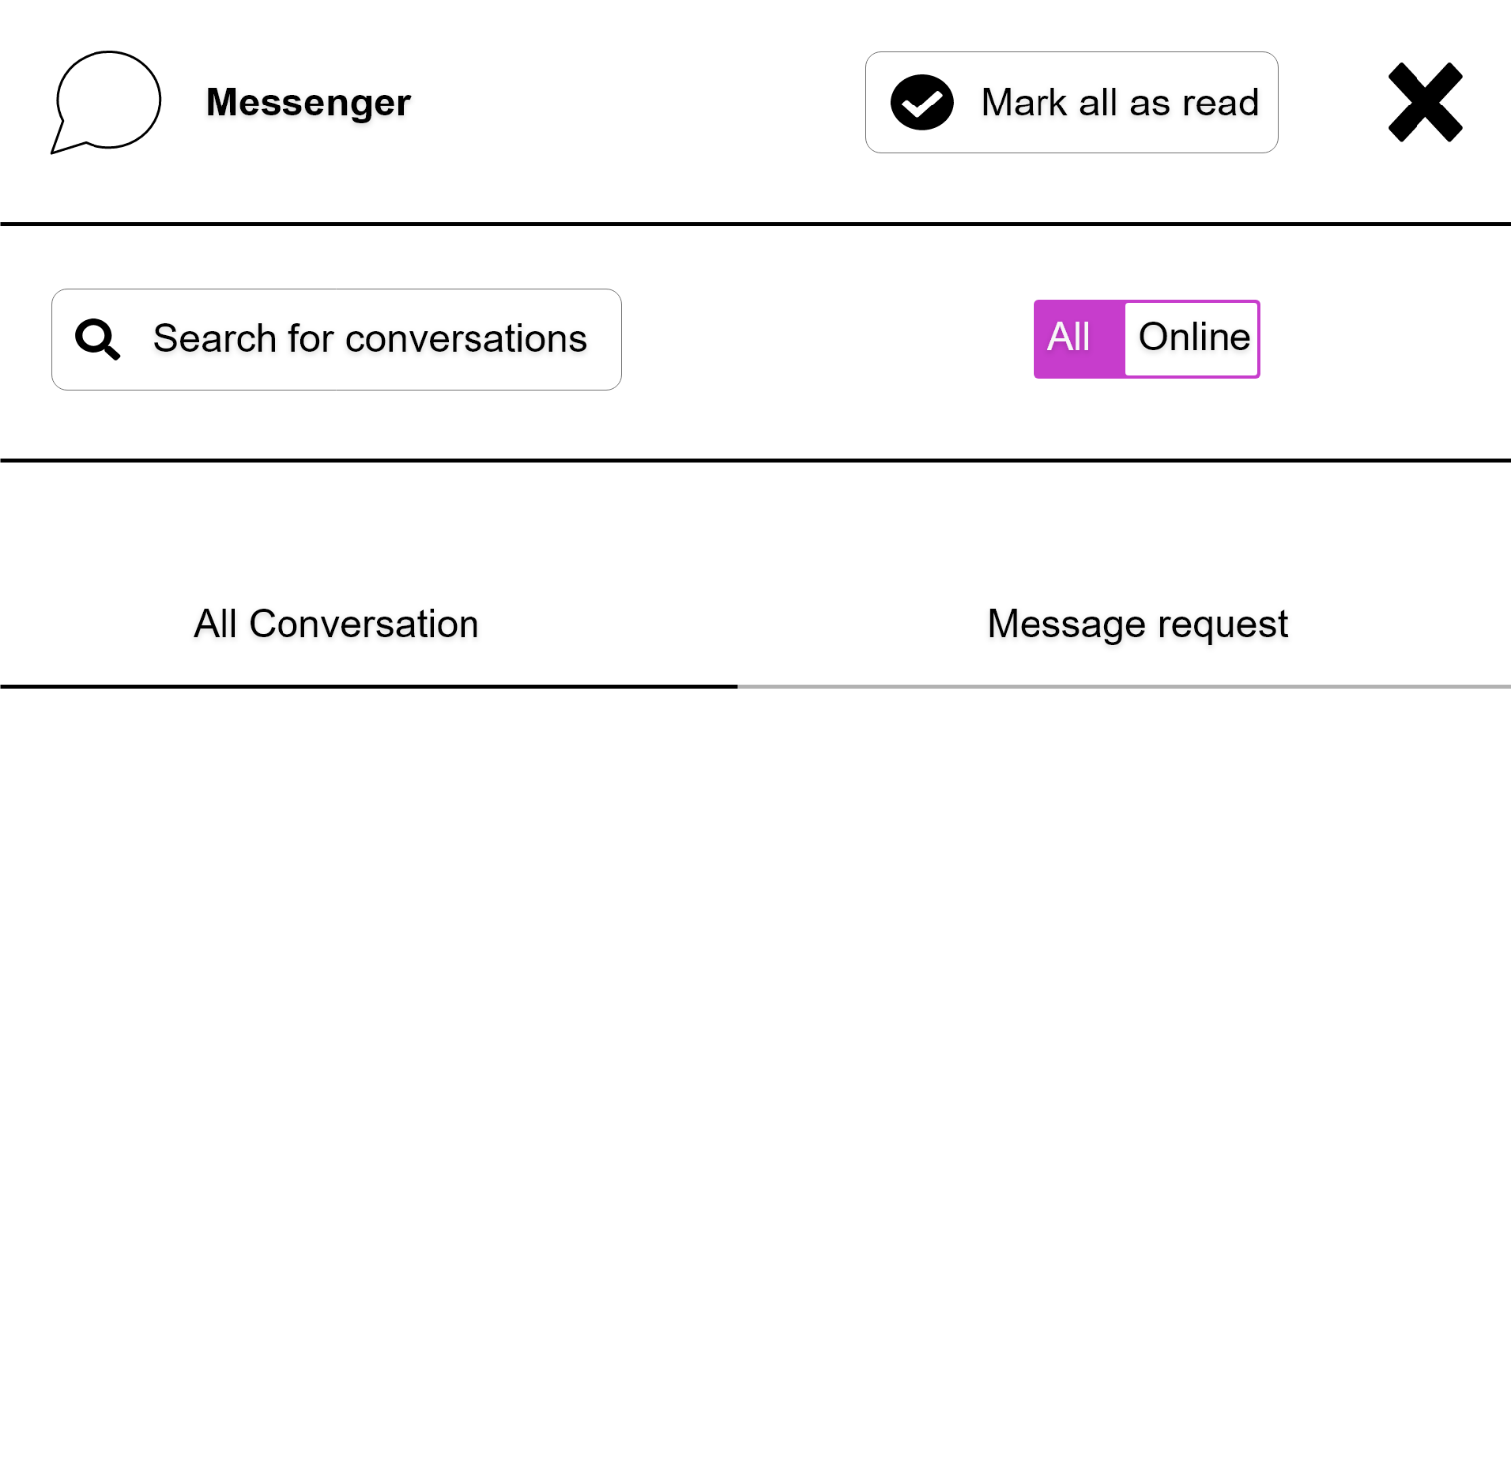

Fig 19: Messaging page

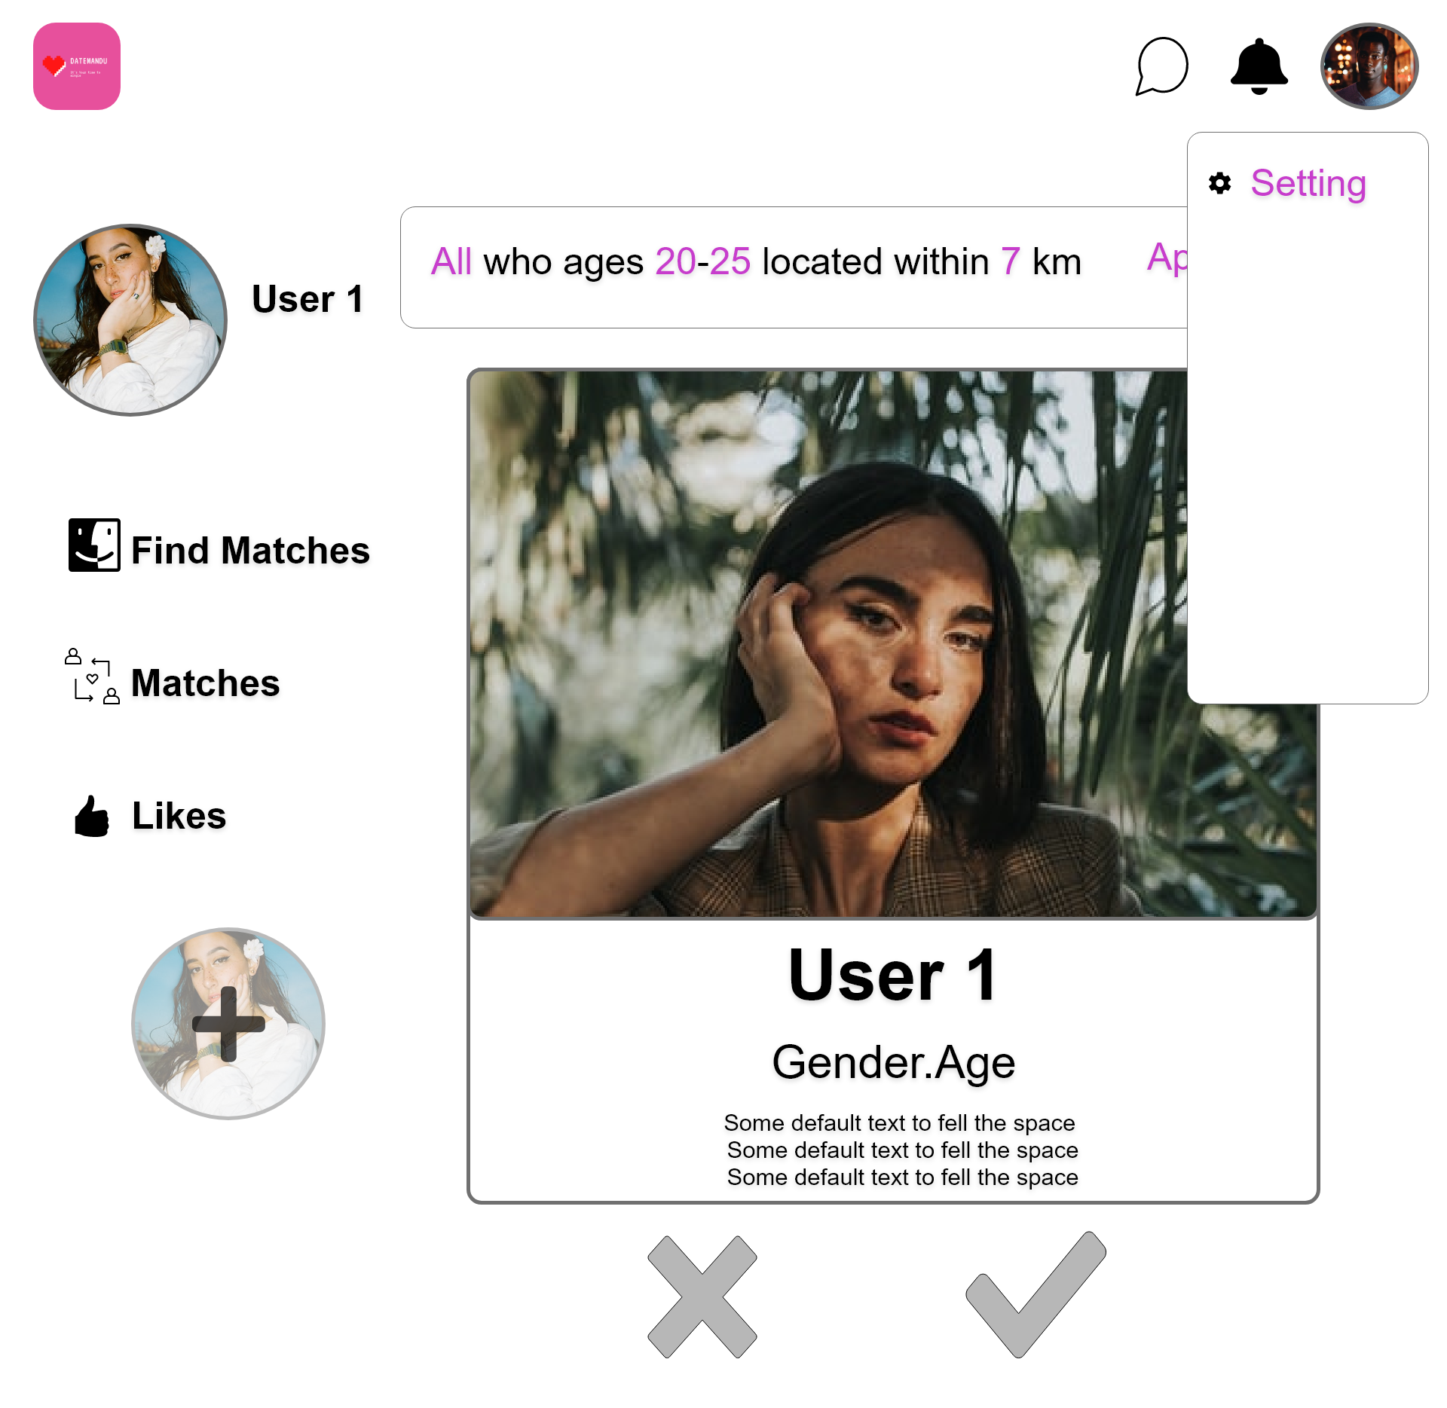

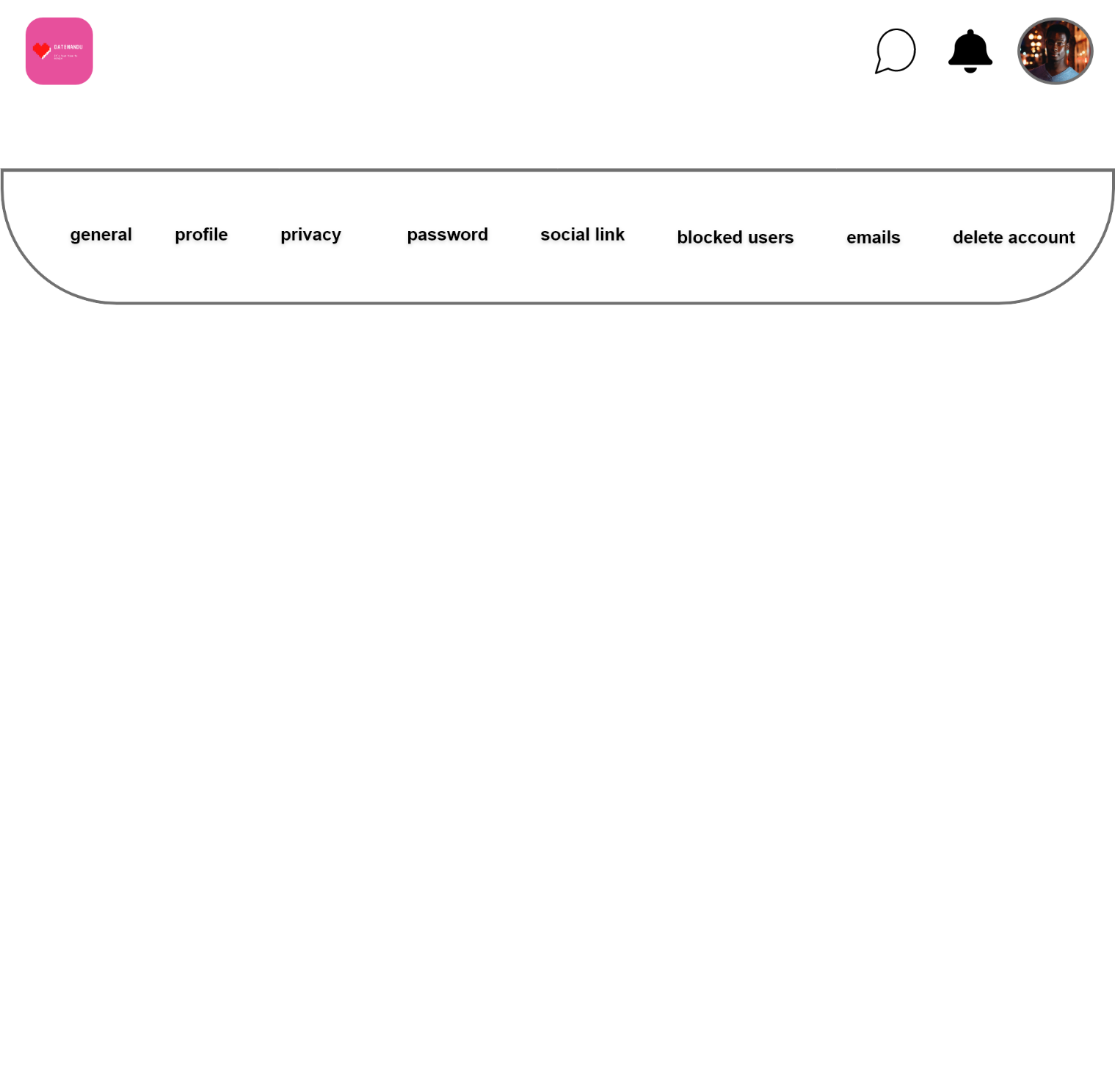

Fig 20: Setting page

Mockups (Android and iPhone)

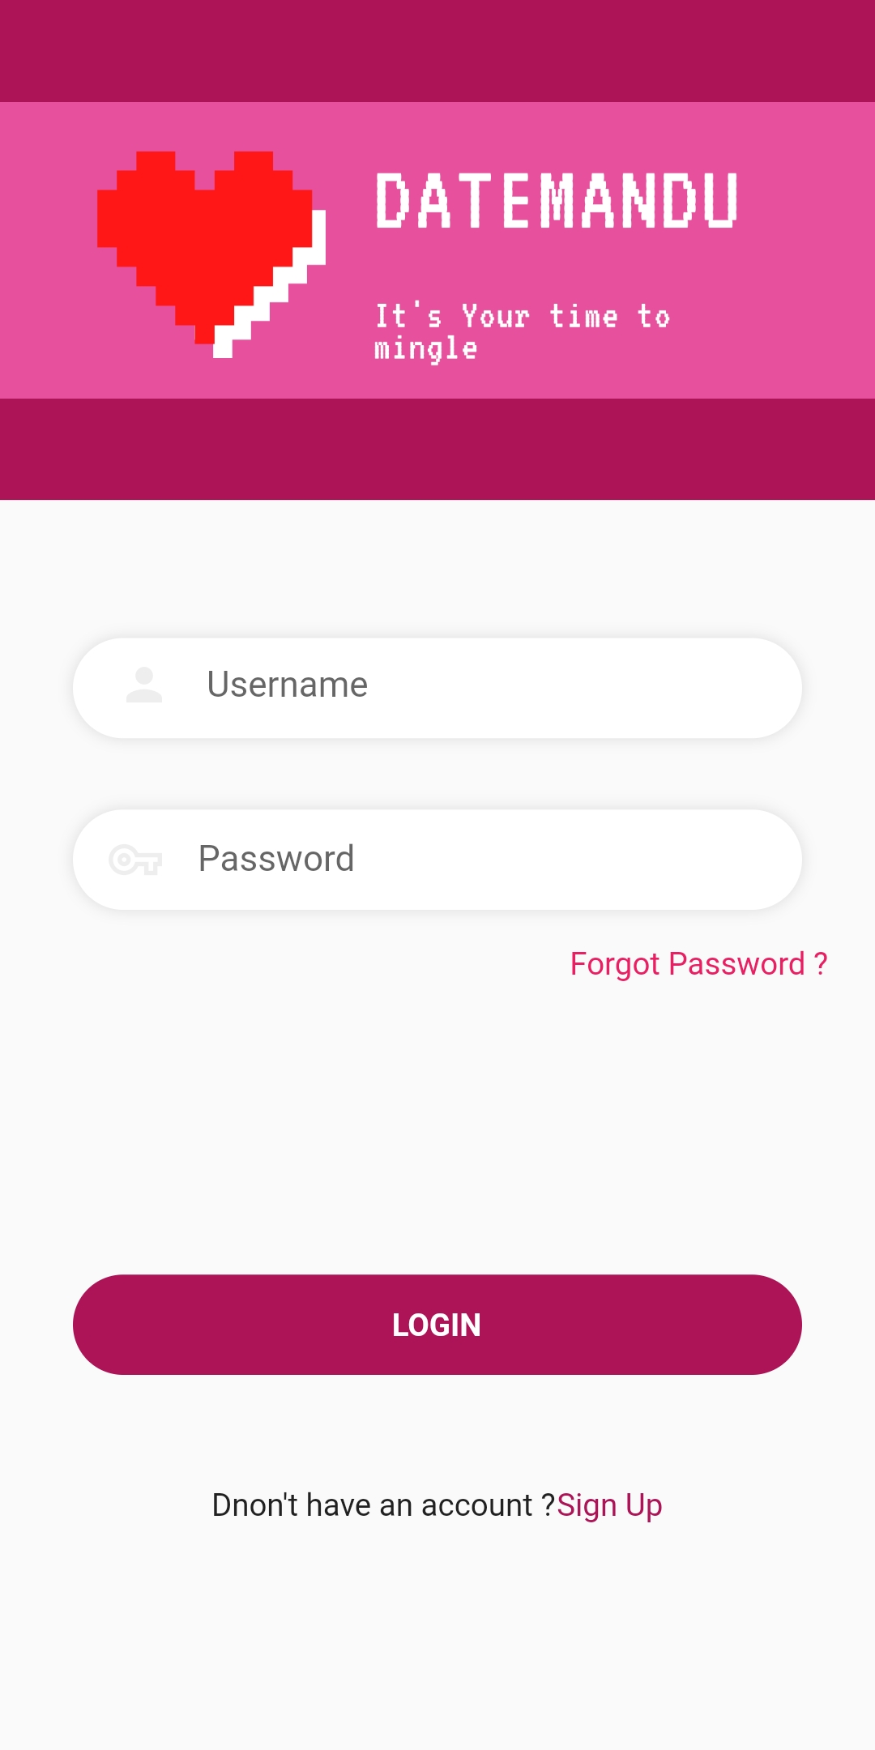

Fig 21: Login page

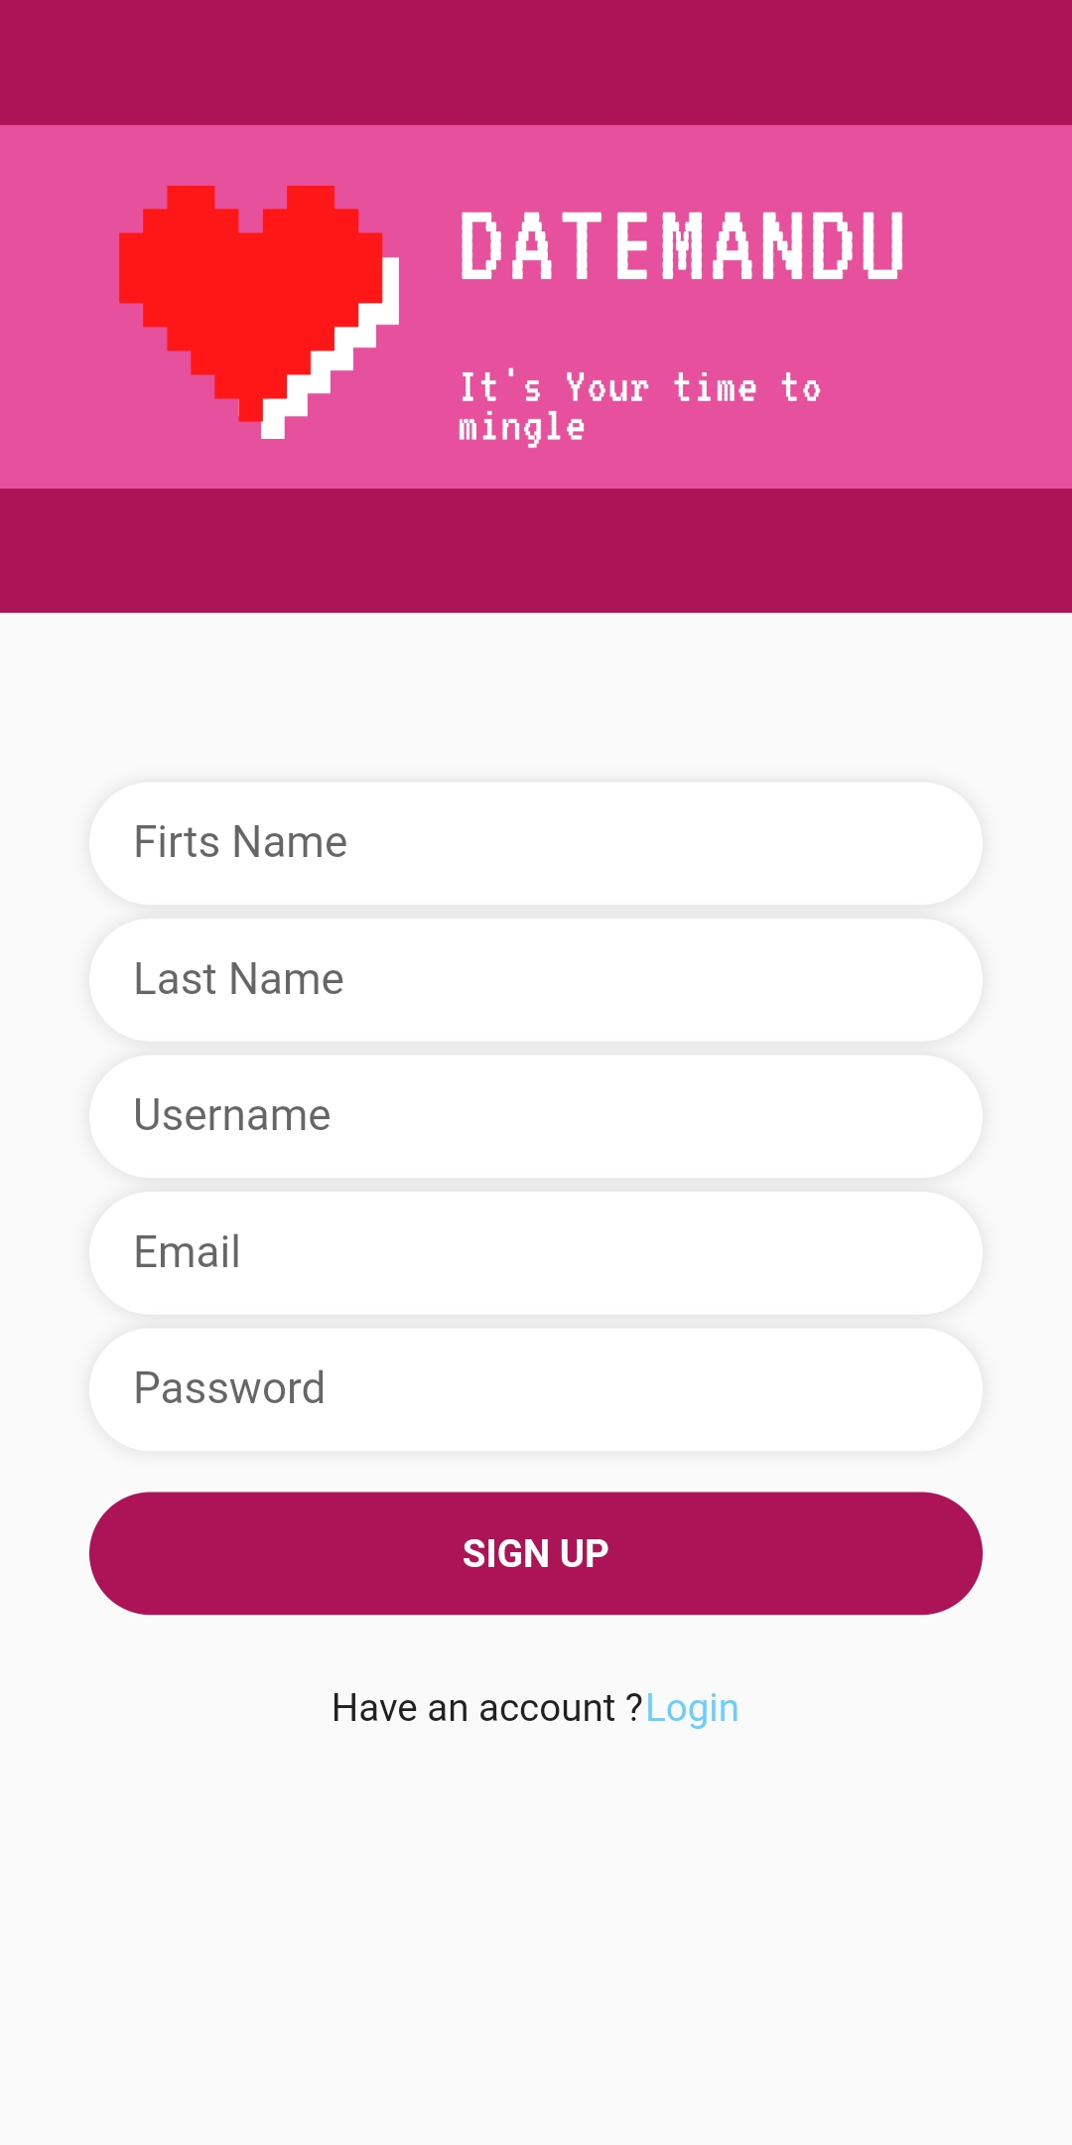

Fig 22: Sign Up page

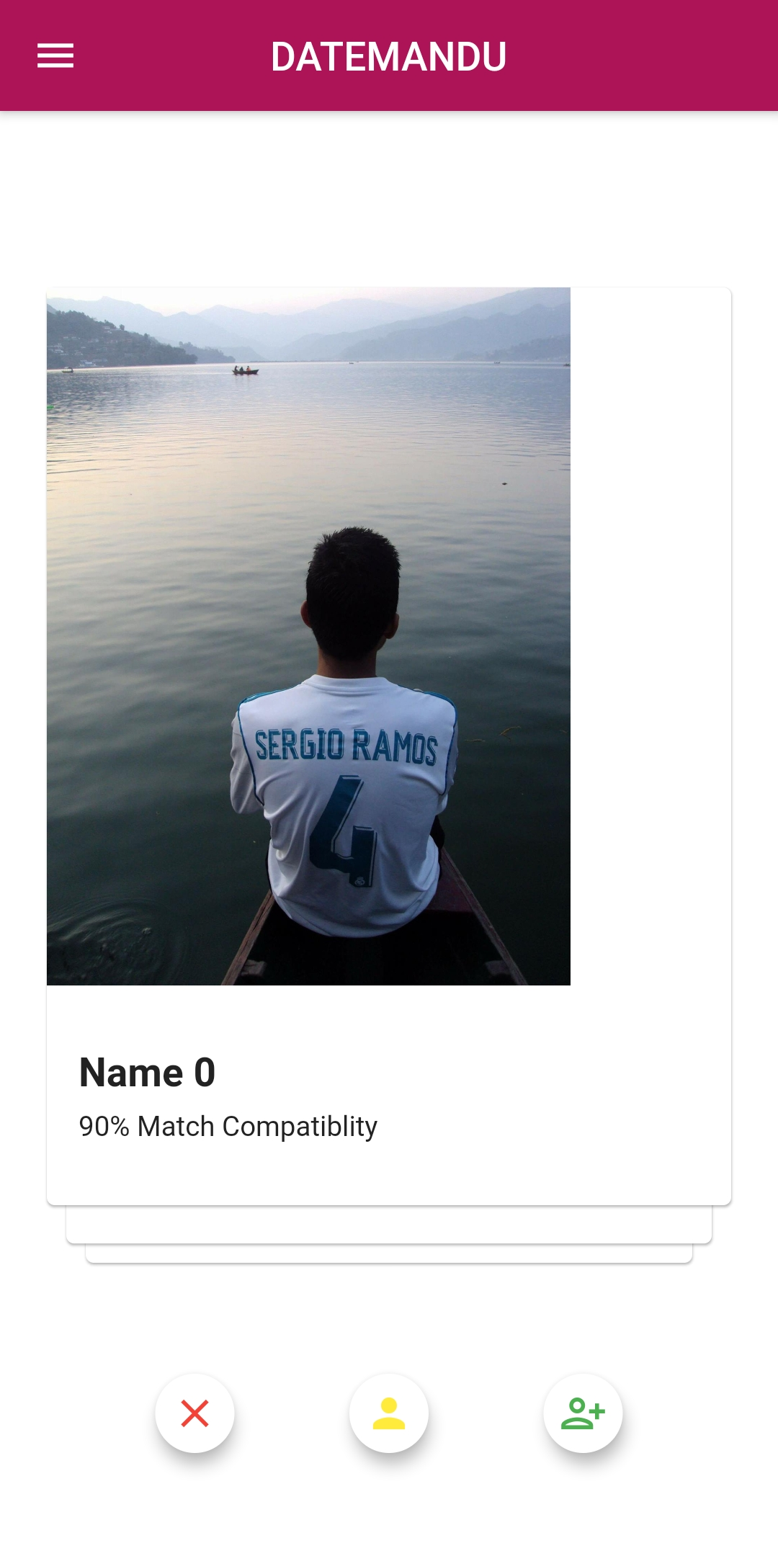

Fig 23: Swipe page

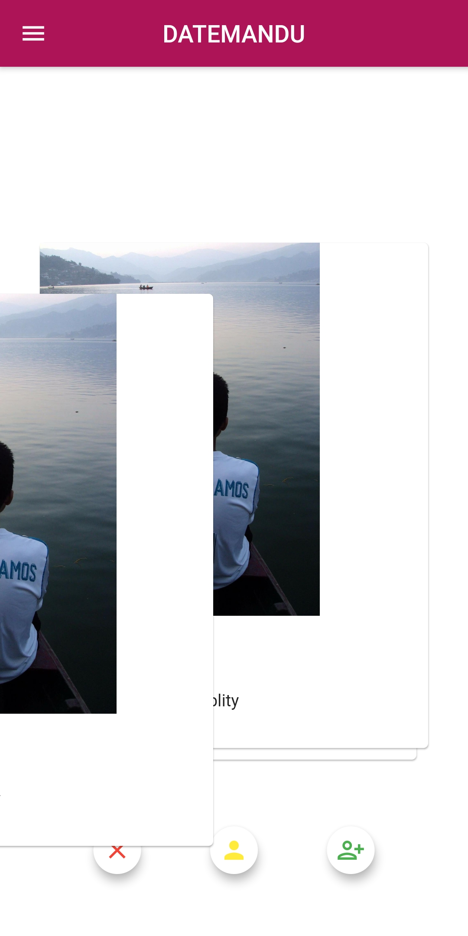

Fig 24: Swipe left

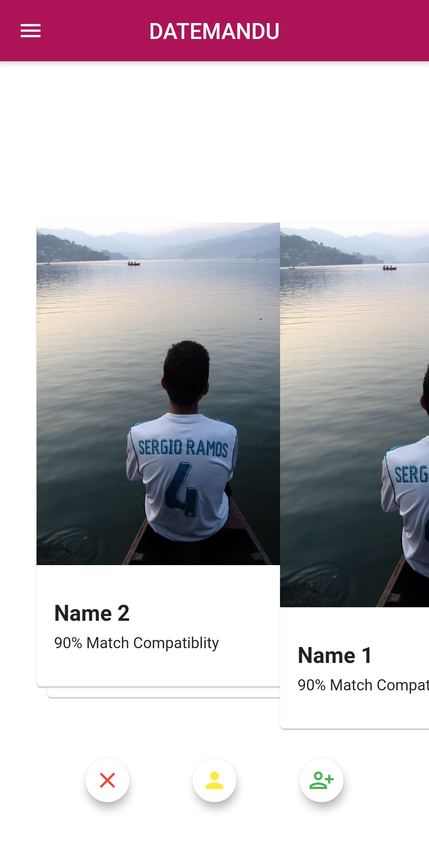

Fig 25: Swipe right

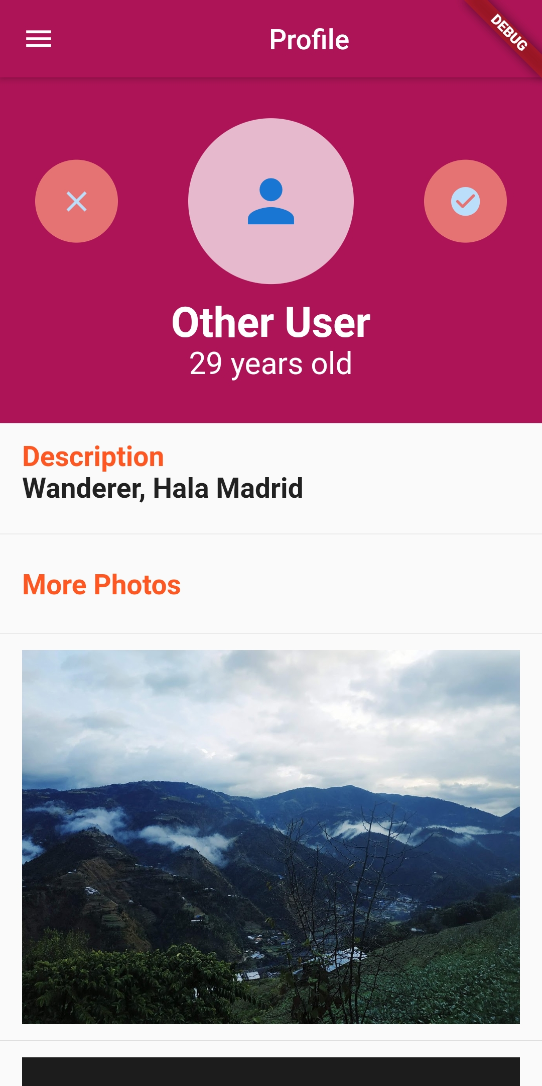

Fig 26: Profile page

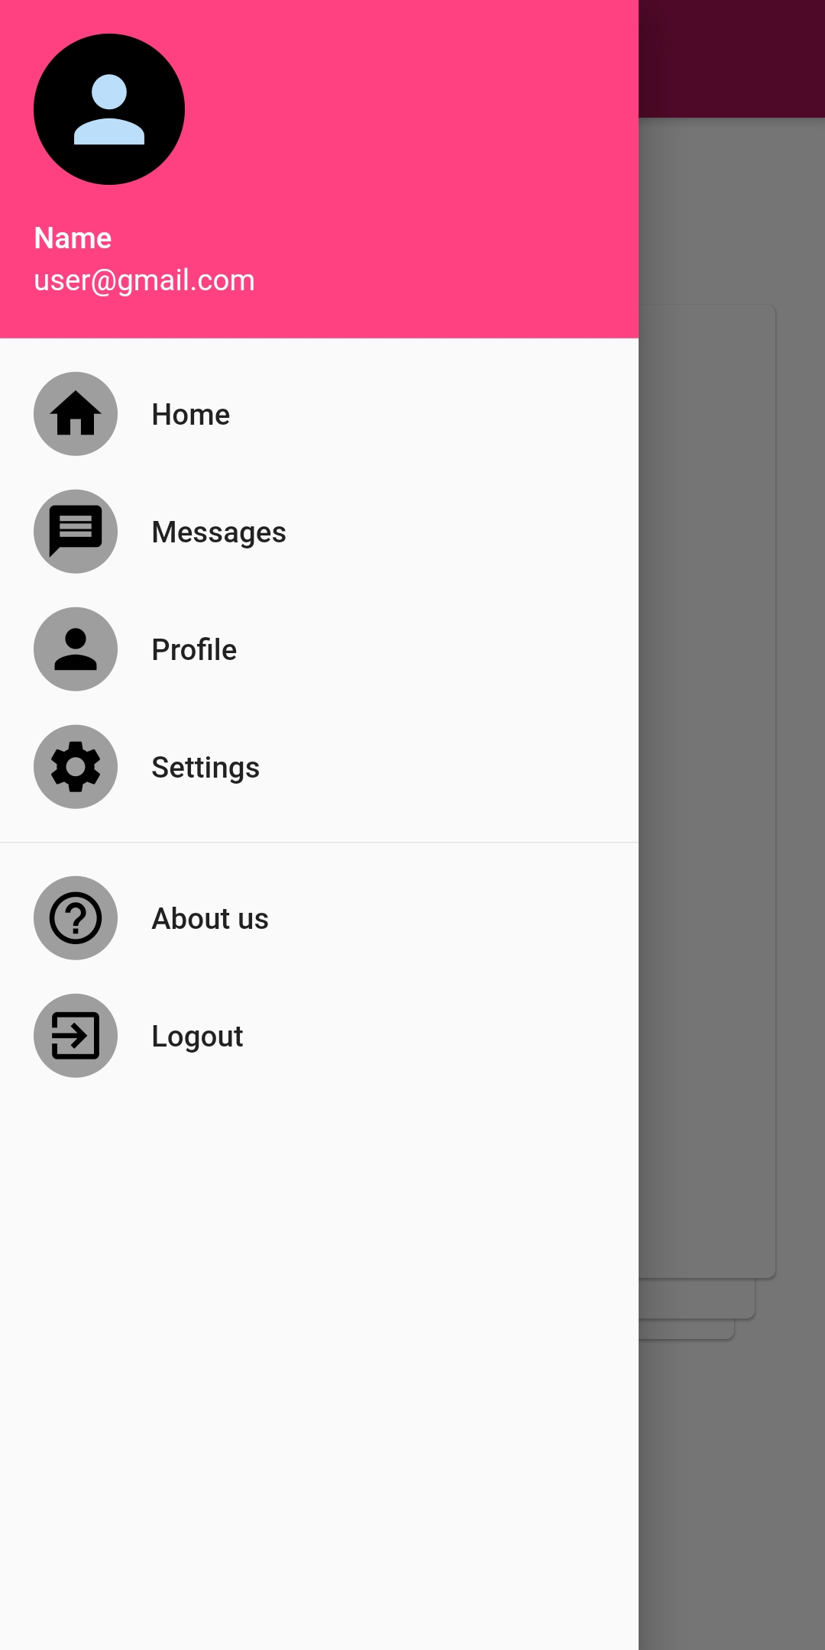

Fig 27: side bar

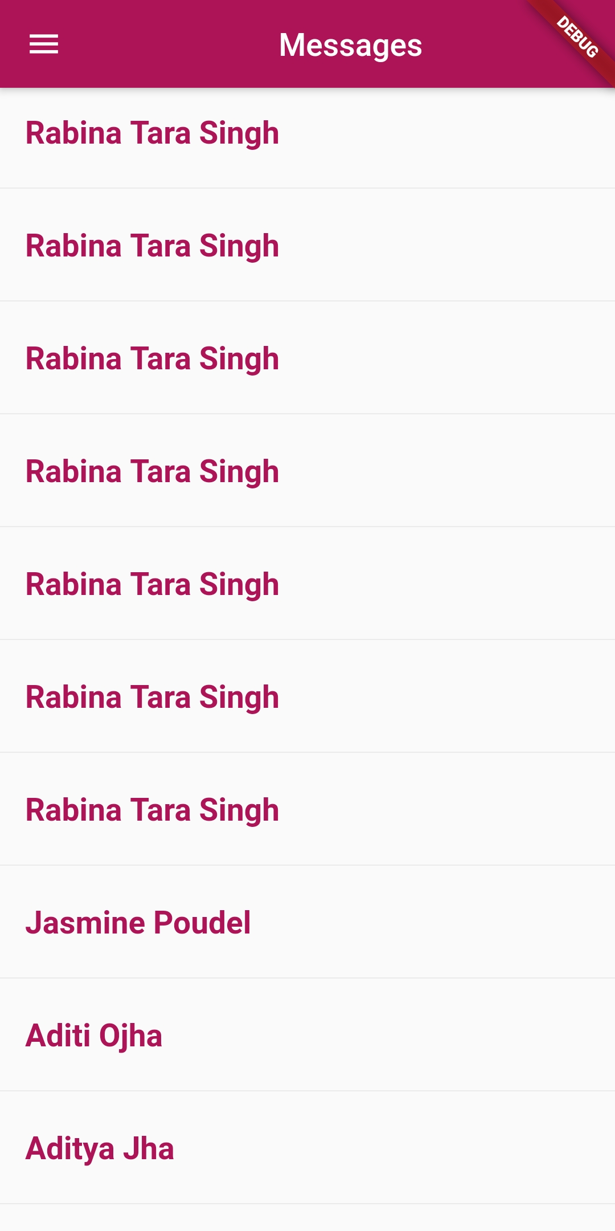

Fig 28: Message page

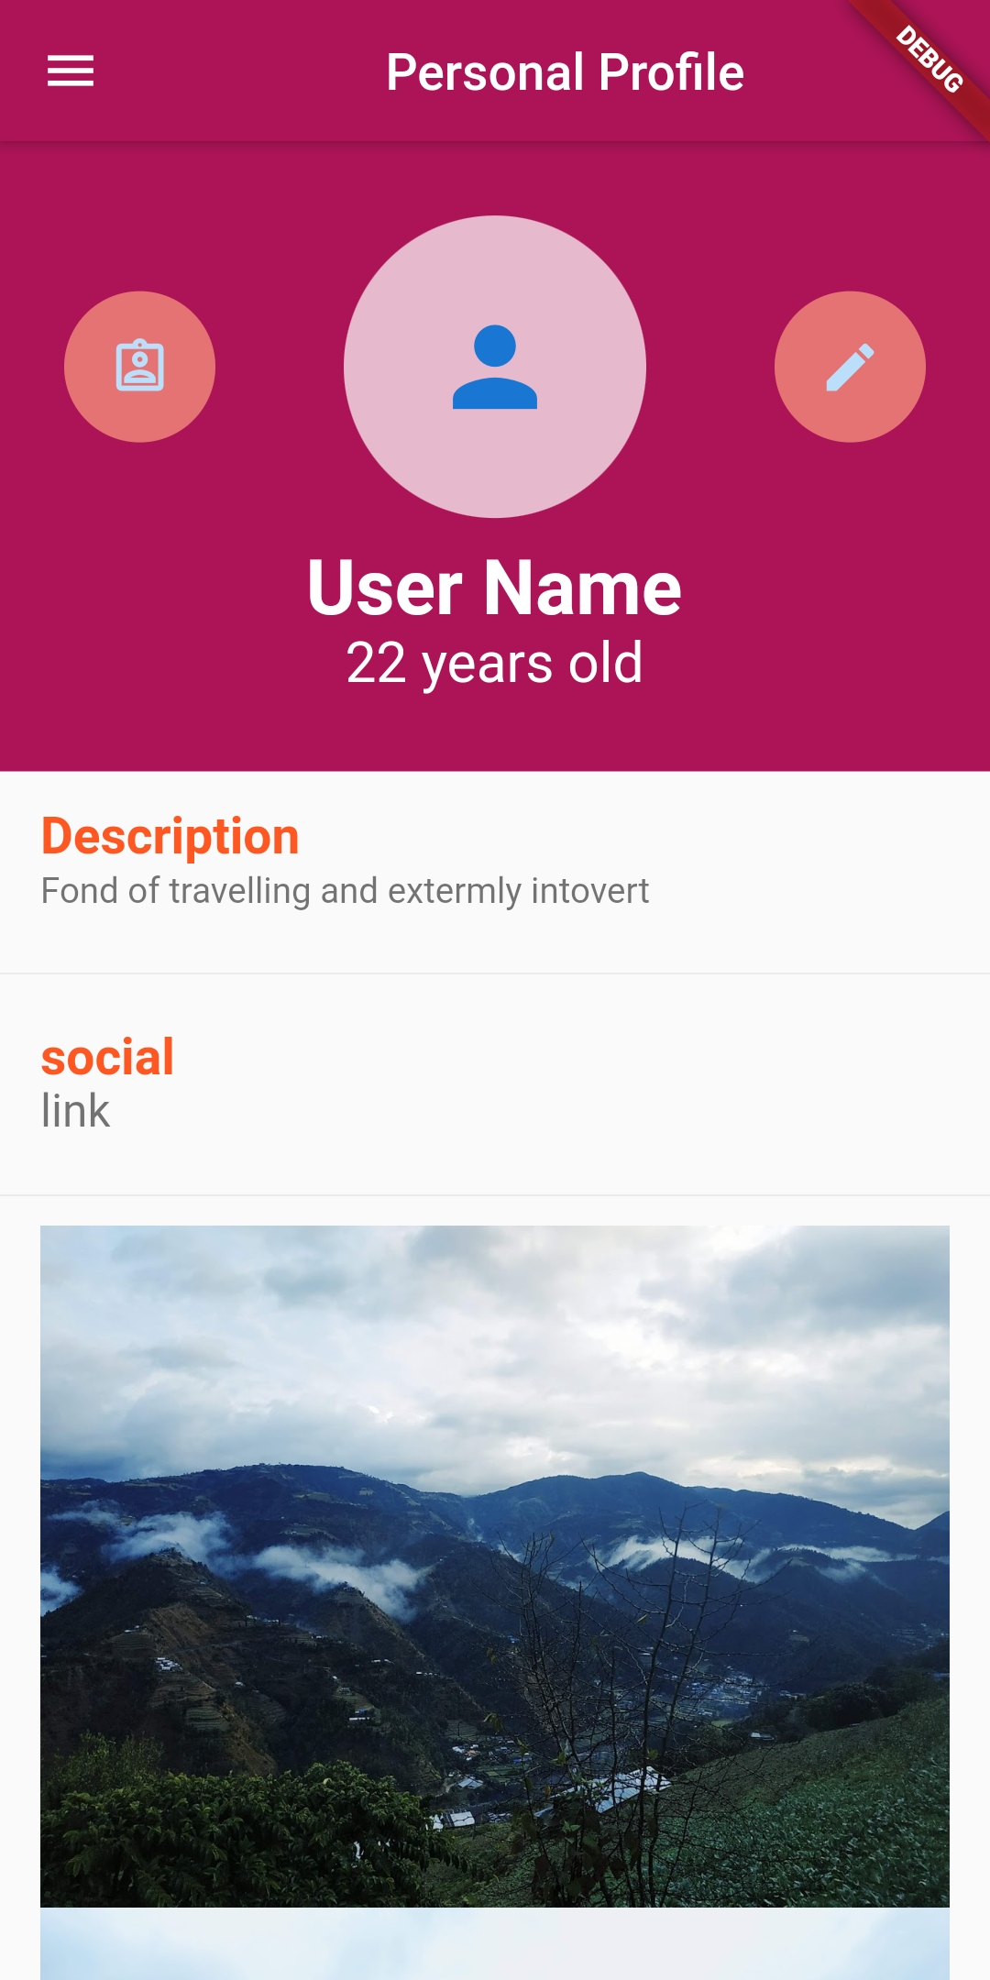

Fig 29: Personal profile page

Conclusion

As we went through this session we ended up with a web-application and mobile application after creating wireframes and mockups. This prototype will help singles to find their partners with our advanced algorithm.

Missing parts will be further covered and implemented in the project as the project is in version 0.

In future voice calls and video chat option will also be provided with proper security options. The terms and conditions will also be enhanced for the better use of the app.

We shall provide different gaming services throughout our app and different offers which will help the users.

As for our revenue we will be showing personalized ads to our users which they will also enjoy to know about.

In conclusion, we created a prototype within 24 hours and we will further enhance and complete it in the future.